ACTIVITY- BF1BAGHOUSEMAINTENANCE ________________________________________________________________________
- Objective : - Safe working procedure for BF1 bag house maintenance
- Scope : - Blast Furnace Accessories
- Ref. : - DISA operation and maintenance manual
- Responsibility : - Engineer in charge and workmen on job

PPE –s to be used :

SAFETY Helmet, Safety shoes, goggle, hand gloves, Co monitor, full sleeve apron and dust mask if working in lime area, safety belts while working at height.

Aspect – Impact :
Scrap generation Resource Depletion
Oil spillage Land contamination and resource depletion
Oil traced waste generation Land contamination and resource depletion

Note : There are 2 filters for BF1 bag house namely Filter A and Filter B. For maintenance/weekly changeover, production, electrical and instrumentation are to be informed. There is one manual damper at filter suction duct above the filter Two electrically operated dampers, named as "BF#1 ISOLATION DAMPER" & "BF#2 ISOLATION DAMPER", had been installed to isolate BF#1 & BF#2 Cast house from each other
Work No 1 : ID fan maintenance.
Work No 2 : ID fan V-Belts replacement /Belts tensioning
Work No 3 : Rotary Airlock (RAL) Valve maintenance
Work No 4 : Radial Fan maintenance
Work No 5 : Motor controlled throttle valve maintenance.
Work No 6 : Cassette Filter – Type GTFSL maintenance
Work No 7 : Deflecting Station with Indexing Disc maintenance
Work No 8 : Lime dosing unit maintenance
Work No 9 : Ladle hood maintenance
Work No 1: ID fan maintenance.
Design
The centrifugal fan is designed in the following version (type of drive):
The impeller is connected to the 3-phase AC motor by a rotor shaft and V-belts.
The radial fan consists of : 1. Spiral housing
2. Impeller
3. V-belts
4. V-belt pulley
5. Drive motor
6. Inlet Guide Vane
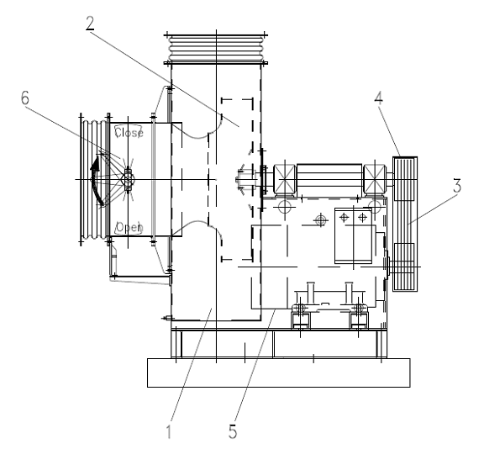Functioning: The impeller is connected to a 3 phase AC motor by a rotor shaft and V belts. The fan consists of Spiral housing, impeller, V belts (8 nos), V belt pulley(C 234), drive motor and inlet guide vane. The centrifugal fan is suitable for conveying gaseous, dust free and non explosive media. Due to rotation of the impeller, the suction is created which results in retaining dust on the filter bags and clean air travels to the fan. The clean air then blown out into the atmosphere though chimney.
1. Take clearance from production and work permit.
2. Check vibration reading acceptable limit is 50 microns
3. Take electrical shutdown of ID fan.
4. Open inspection door, check impeller for any crack or deformation.
5. Check all foundation bolts for tightness.
6. Check ID fan bearings and lubricate.
7. If bearings are to be inspected by removing the top half of Plummer block, the shaft has to be locked. Since the fan assembly is overhung design, the impeller assembly may get lifted up if top half of drive end Plummer block removed without proper locking. Support / Locking to impeller to be provided before opening plummer block. If bearing is to be removed at the drive end, due to eccentricity, it is to be supported with clamps/supports.
8. While rotating the impeller with V belts in position, care should be taken for entanglement of fingers in between V belt & pulley groove.
9. Follow procedure of WI/MAINT/06 for assembly changing, damper changing, and expansion bellow changing & balancing of ID fan.
10. Clear shutdown and take trial.
11. Hand over to production.

Work No.2: ID fan V-Belts replacement /Belts tensioning

1. Take clearance from concerned Production engineer.
2. Take electrical shutdown of equipment
3. Mark the position of foundation bolts of motor with chalk/paint to reduce the alignment timing after belt replacement.
4. Remove the belt guard & release the tension of belt by loosening the belt tensioning bolt of motor foundation frame.5. Now replace all damaged belts (C-234 – 8 nos) one by one.
6. Now start tightening the belt tensioning bolts and return back to the postion where marking is done.
7. Check alignment of pulleys with piano wire.
8. Fix back the belt guard & clear electrical shutdown.
9. Take trial & give clearance.

Work No 3: Rotary Airlock (RAL) Valve maintenance.
Design
The rotary air valve consists of:1. Valve housing
2. Geared Motor
3. Rotor
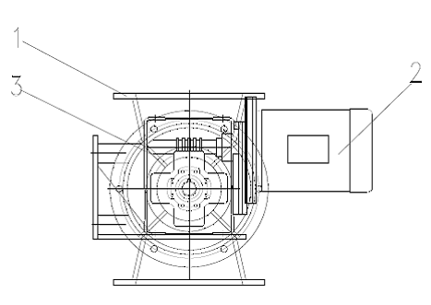
Functioning: The RAL is used for the continuous discharge of the separated dust. The rotor blades are mounted on a shaft which is coupled to a hollow shaft geared motor. The dust discharged from the hopper is collected in between the rotor blades. Due to the rotary motion of the shaft the dust collected between the pockets is discharged through the outlet of the casing.
1. Take clearance from concerned Production engineer.
2. Take electrical shutdown of RAL.
3. Inform electrical to disconnect the motor cables before removing the fittings.
3. Loosen the RAL housing flange connection to hopper bolts and insert a blank (plate) between the hopper and the RAL so that the accumulated material in hopper does not fall on ground during RAL removal.
4. Remove the geared motor assembly bolts and remove the motor assembly by using fabricated puller. Ensure that fabricated stand is used for keeping the geared motor assembly and take care of the electrical cables while removing the motor.
5. Try to make the rotor free inside the valve housing using pipe wrench. If it is jammed, remove the rotor by hammering the shaft with a wooden block.
6. Clean the rotor blades and the valve housing thoroughly to remove the jammed material.
7. Fit back the rotor in the valve housing and fit back the geared motor assembly. Check the oil level of the gearbox through the sight glass. If oil level is low, top up oil in the gearbox (SP – 320).
8. Remove the hopper blank, tighten the flange bolts.
9. Check the wire rope, bull dog clamps of the hopper vibromotor for any wear and tear and any looseness.
10. Inspect the hopper inspection doors sealing gasket and hopper door locking arrangement.
11. Inform electrical to connect back the supply cables to motor.
11. Clear the electrical shutdown of the RAL.
12. Take trials and note down the current readings.
13. Give clearance to production to use the filter.
Work No 4: Radial Fan maintenance.
Design
The impeller is mounted directly on the motor shaft.
The cleaning air radial fan consists of:1. Spiral housing with impeller
2. 3-phase AC motor
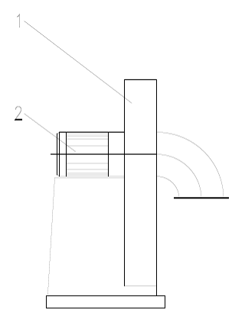
Functioning:
The impeller is mounted on the motor shaft. The cleaning air radial fan consists of spiral housing with impeller and 3 phase AC motor. This fan is suitable for conveying gaseous, dust free and non-explosive media. The motor drives the impeller. Due to rotation of the impeller the gaseous medium is blown out through the pressure opening while at the same time a negative pressure is created at the intake opening, generating a flow in the connecting piping system.

- Take clearance from concerned Production engineer.
- Take electrical shutdown of RA fan.
- Open the inspection door of the housing for checking the impeller.
- Check the impeller for any cracks, bolts tightness.
- Close the inspection door.
- Check the canvas and hose clamps of RA fan pipe.
- Check for no hole anywhere in RA fan duct to avoid repeated trip due to flux leakage.
- Clear the electrical shutdown.
- Take trials and give clearance to production.

Work No 5: Motor controlled throttle valve maintenance.
Design:
The throttle valve consists of:
1. Valve housing
2. Flaps
3. Actuator
Functioning:
The throttle valve consists of valve housing, flaps and actuator. The valve housing is out of fabricated steel with bearing bushes and two flanges. The valve is screwed to a shaft which is on one side connected to the respective adjustment mechanism. The size of the valve is established to suit the free cross section and the prevailing negative pressure. The shafts are mounted in maintenance free sintered or sliding bushes. The adjustment possibility is described by an actuator with hand wheel. The actuator is attached to the valve housing. The actuator is connected on one shaft end and lever by means of linkage to the valve shaft. The position of the valve is controlled by the actuator. The throttle valve is used to regulate the volume flow. The extraction volume is regulated and set by the adjustment of the valves in the OPEN – CLOSED range.

- Take clearance from concerned Production engineer.
2. Take electrical shutdown of actuator.
3. Check the valve operation by operating in manual mode by operating the hand wheel. For engaging in manual mode, engage the lever by operating in forward direction.
4. Check the valve for any jamming.
5. Check the actuator gearbox oil level and top up if required.
6. Do greasing of 4 pivot points of the ID fan actuator, Inlet Guide Vane (IGV) moving parts.
7. Clear the electrical shutdown and take trials.
8. Give clearance to production.
Work No 6: Cassette Filter – Type GTFSL maintenance.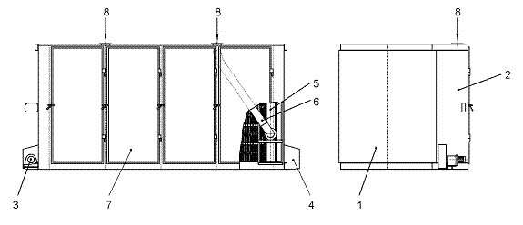
The cassette-type filter of the series GTFSL consists of above diagram: the cassette-type filter housing (welded assembly) the individual cassette-type filter sizes are assembled from several elements and welded together. This guarantees an absolute leak-tight design. The drive station is arranged on the left-hand side as a standard feature. Cassette-type filter housing consists of a left-hand side section, a right-hand side section and, depending on requirements, one or several individual back and slotted walls of various sizes. The slotted wall in the cassette-type filter housing separates the dust laden air and clean air chambers. The clean air chamber forms a closed chamber with the bottom and top plates. A track is mounted on both the bottom and top plates to guide the cleaning cars. Depending on the number of cleaning cars, connecting branches are provided in the top plate for the cleaning air valves and cleaning hoses.

The assembly components:
These are both individual parts as well as assemblies which are installed in and on the
Cassette-type filter housing (e.g. cleaning cars, cleaning air facility, drive unit, filter bags,
Protection sections in the case of abrasive dusts).
1. Dust laden Air chamber.
2. Clean air chamber.
3. Drive station
4. Deflecting station
5. Cleaning car with cleaning nozzle
6. Cleaning hose
7. Housing door
8. Cleaning air inlet

The material quality of the filter bags and the cleaning hose is established to suit the plant
In question. Access to the filter bags, the cleaning nozzle and the cleaning hose is
Guaranteed through large housing doors on the clean air chamber side.
The filter bags are arranged horizontally in the dust laden air chamber and pressed against
the slotted wall and sealed with segment frames and spring clip. The spacer mat inserted
into each filter bag prevents contact with the filter bag inside surface when dust is being
Separated
The vertically arranged cleaning nozzle covers three adjacent vertical bag rows. Free
access for the cleaning air is only provided for the middle bag row. This prevents the intake
of dust dislodged from the neighboring filter bags during the cleaning process. The
cleaning nozzle is driven by a chain/rope drive mechanism. The drive station is located
outside on the cassette-type filter housing.
The cleaning air facility with cleaning air fan and cleaning air valve is mounted on the clean
air chamber and connected to the cleaning nozzle by a flexible hose.

Functioning
The dust laden gases are cleaned in the dust collection plant and the separated dust is
discharged. These processes take place as follows
The dust laden gases pass through the polluted process gas hood from above into the polluted process gas chamber and flows through the filter bags to the clean air chamber. The dust is retained on the outside surface of the filter bags.
The dust adhering to the filter bags is removed fully automatically (online) during the dust
collection process by a counter current air stream. The cleaning air radial fan generates the
required amount of air and the cleaning air valve provides the pulse required for cleaning.
The cleaning air pulse blows the filter bags up and the adhering dust is thus dislodged.
The cleaning car with the cleaning nozzle moves in cycles from bag row during the
cleaning process. The exact position of the cleaning nozzle in front of each bag row is
governed by an indexing mechanism.
The filter bag cleaning system is triggered on expiry of a preset time (parking time). The
cleaning cycles depend on the type of dust and the polluted process gas content.

1. Take clearance from production.
2. Take shutdown of ID fan of the filter where the bags are to be checked.
3. Remove the locking chain of the door and open the door of the filter bags.
4. Check the condition of the filter bags. Check the inside of doors for any graphite or lime marks. If the marks are very prominent, it indicates that the respective bag is damaged.
5. Replace the damaged bag immediately.
6. Check the cleaning carriage wheels for wear and tear and do greasing of wheels.
7. Check the cleaning hose for any damage.
8. Check the wire rope and carriage coupling.
9. Check the door sealing gaskets for any damage to rubber.
10. Close the filter doors properly after completion of maintenance and lock the doors.
11. Fix back the door locking chain and clear the ID fan shutdown.
12. Take trials of the filter and give clearance to production.

Work No 7: Deflecting Station with Indexing Disc maintenance.
The mechanical section for the indexing mechanism is integrated in the deflecting station.
The deflecting station is located on the right outside of the cassette-type filter housing
(standard design). The deflecting station is protected by a cover. (see fig.2)
The assembly components of the indexing mechanism are:

1. Bracket
2. Indexing disk
3. Pulley
4. Limit switch
5. Inductive switch
6. Cover

Functioning:
The deflecting station with indexing disc is used to control the cleaning car in the cassette type
filter. This process is carried out as follows: When the cleaning car advances, the indexing disc is entrained by the pulley through frictional contact. When a tooth comes to the inductive switch, the cleaning car with the cleaning nozzle stops exactly in front of the bag row in question. When the cleaning car reverses (continuously without indexing), the indexing disc is blocked after one revolution, which means that tooth No. 1 stops in front of the inductive switch. This ensures that the indexing disc is always brought back to its correct starting position again after each cleaning cycle. As soon as the cleaning car has activated the limit switch on the deflecting side, the cleaning nozzle is always positioned in front of the first bag row.
The indexing mechanism does not require any setting work even after the replacement of
the chain and rope, which will be necessary at some time during the life of the plant.

- Take clearance from production.
2. Take shutdown of ID fan of the filter where the indexing disc is to be checked.
3. Check the indexing wheel for any wear and tear.
4. Check the indexing mechanism gearbox oil level. Top up if required.
5. Check the coupling of indexing mechanism and motor for any looseness.
6. Check the idler pulley on wire rope side for freeness.
7. Check the flap valve for freeness on shaft, flap valve coupling for looseness.
8. After checking, clear the shutdown of the fan and give clearance to production.

Work No 8: Lime dosing unit maintenance
- Ensure that the people working in the lime area wear full sleeve apron.
- Ensure that people are wearing dust mask while working
- Take electrical shutdown of RAL and lime FD fan.
- For RAL maintenance, follow Work No. 3 procedure.
- Check the lime beater assembly for any damage and do greasing of the chain.
- Check the sealing gasket and locking arrangement of lime hopper loading latch for any wear out.
- Check the lime FD fan foundation bolts for tightness and physical damage.
- Clear the electrical shutdown and give clearance.

Work No 9: Ladle hood maintenance
- Take work permit from production engineer.
- Ensure that the ladle hood is in retracted position. Take electrical shutdown of electric winch of the ladle.
- Check the wire rope of the winch for any damage. Replace if it is damaged by following steps from 4 o 10.(26 mts long)
- Keep the ladle hood at the retracted position.
- Take electrical shut down of the drive and take permit from control room.
- Remove the wire rope from the central D-shackle and unwind the wire rope.
- Lay new wire rope of 26 mts length. in the same fashion it was removed.
- Take trials of the ladle hood and check for any additional stress coming on any wire rope.
- Clear the shut down and permit once trails are found to be ok.

- Check the pneumatic dampers of the ladle hood by operating. Tighten the bolts if found loose.
- Clear the electrical shutdown and take trials.

GENERAL DOS AND DONTS FOR THE ABOVE PROCEDURE:

DOS:
- Ensure that the fans must run in the direction of the arrows.
- Ensure the housing doors and protective covers to be closed on completion of cleaning and repair work.
- Ensure that the filter bag doors are closed and locked with chain before starting the filter.
- Ensure before starting maintenance and repair it is absolutely necessary to wait until the impeller of the radial fan stands still.

DO NOT:
- Carry out gas cutting/welding activity in close proximity of the bag filters as it can cause fire.
- Start the filter when the filter bag chamber door is open as it will hit a person due to draft in the system.
- Allow moisture to enter the filter bags as it will lead to material jamming.
- Bypass any safety interlocks/alarms.
- Switch ON the radial fans unless intake and discharge openings are closed with piping, suitable grids or steel sheet covers.
- Remove the protective covers while the dust collection plant is in operation.

Hazards identified:

Mechanical Hazard:
1. Fall of person from height.
2. Trapping in between bag house doors, moving components, moving ladle trolley, V belts, etc.
3. Fall of equipment parts during dismantling.
4. Trapping of fingers between the RAL blades during bags/RAL cleaning.
5. Contact with hot metal during ladle hood maintenance.
6. Hitting of filter door on person if door is not locked and filter is started
7. Fall of person inside duct/hopper while filter checking.
8. Trapping in between the Inlet Guide Vane (IGV) moving parts.
9. Trapping in between the filter bags frame and cleaning carriage assembly.
10. Trapping in between lime beater assembly/drive chain.
11. Fall of person inside lime hopper.

Physical Hazard:
- Noise, pressure, temperature
- Slipping due to accumulation of graphite/poor housekeeping.
- Back pain due to sudden or heavy load like motor/heavy pulley, etc.

Human behavior:
- Workmen nature, alcoholism, casual approach & non usage of correct tools & PPE.

Electrical Hazard:
- Electric shock in welding / equipment

Chemical hazard:
- Fire in Bag house filters.
- Fall of lime powder in eyes, nose, mouth.
- Co gas poisoning.

Amendement Record
Date | Manual Section Ref. & Para | Brief details of Revision | New Rev.

Prepared By:  Area Engineer | Reviewed & Issued By:  Management Representative | Approved By:  Mechanical Head
Signature | Signature: | Signature:
Review Date: 12.12.22 | Review Date: 12.12.22 | Review Date: 12.12.22

